

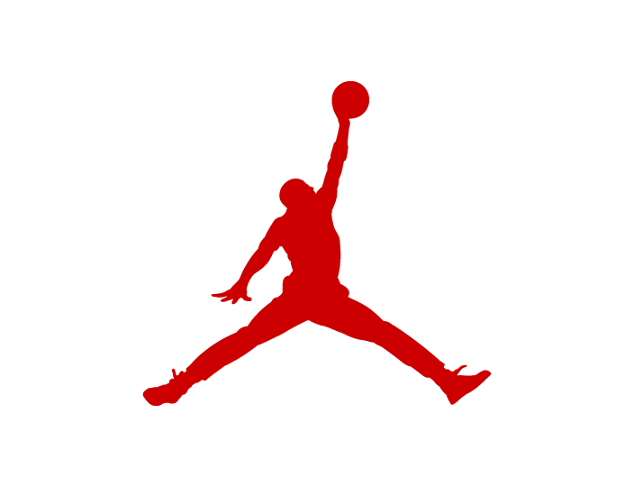

|  | Tipo | Precio |  | Tipo | Precio |
| --- | --- | --- | --- | --- | --- |
| Jordan 3 Mid TD Men's Football Cleats - Black/Cement Grey/White/Fire Red | Jordan 3 Mid TD Men´s Football Cleats | $160.00 | Jordan 2/3 Men's Shoes - White/Sail/Cement Grey | Jordan 2/3  Men's Shoes | $168.00 |
| Air Jordan 6 Retro "White and Midnight Navy" Men's Shoes - White/Midnight Navy/Varsity Red | Air Jordan 6 Retro "White and Midnight Navy"  Men's Shoes | $200.00 | Air Jordan 1 Low SE Men's Shoes - Psychic Purple/White/Cone/Hyper Jade | Air Jordan 1 Low SE  Men's Shoes | $125.00 |
| Air Jordan 6 Retro "Pearl" Women's Shoe - Pure Platinum/Metallic Gold/Coconut Milk/Glacier Blue | Air Jordan 6 Retro "Pearl"  Women's Shoe | $200.00 | Air Jordan 1 Mid Shoes - White/White/White | Air Jordan 1 Mid  Shoes | $125.00 |
| Jordan True Flight Men's Shoes - White/Black/Varsity Red | Jordan True Flight  Men's Shoes | $90.00 | Jordan 6 Rings Men's Shoes - White/Team Red | Jordan 6 Rings  Men's Shoes | $144.97 |
| Jordan Essentials Men's Short-Sleeve Top - White | Jordan Essentials  Men's Short-Sleeve Top | $46.00 | Jumpman MVP Men's Shoes - Black/University Red/Anthracite/Dark Concord | Jumpman MVP  Men's Shoes | $165.00 |
| Jordan MJ Brooklyn Big Kids' Printed Fleece Pullover Hoodie - Sail | Jordan MJ Brooklyn  Big Kids' Printed Fleece Pullover Hoodie | $60.00 | Air Jordan 1 Low FlyEase Men's Easy On/Off Shoes - Black/Cement Grey/White/Fire Red | Air Jordan 1 Low FlyEase  Men's Easy On/Off Shoes | $97.97 |
| Jordan MJ Brooklyn Essentials Big Kids' T-Shirt - White | Jordan MJ Brooklyn Essentials  Big Kids' T-Shirt | $25.00 | Air Jordan I High G Men's Golf Shoes - University Blue/White/Black | Air Jordan I High G  Men's Golf Shoes | $190.00 |
| Air Jordan 1 Mid Sneaker School Big Kids' Shoes - Aegean Storm/Pink Oxford/Red Stardust/Hemp | Air Jordan 1 Mid Sneaker School  Big Kids' Shoes | $102.00 | Air Jordan 3 Retro Women's Shoes - White/Sail/Cement Grey/Cosmic Clay | Air Jordan 3 Retro  Women's Shoes | $200.00 |
| Jordan 3 Retro MCS Men's Baseball Cleats - Black/Cement Grey/White/Fire Red | Jordan 3 Retro MCS  Men's Baseball Cleats | $190.00 | Air Jordan 1 Mid SE Women's Shoes - Smoke Grey/Sail/Off Noir | Air Jordan 1 Mid SE  Women's Shoes | $101.96 |
| Jordan Hydro 4 Retro Men's Slides - Off White/Neutral Grey/Industrial Blue | Jordan Hydro 4 Retro  Men's Slides | &63 | Tatum 2 Basketball Shoes - White/Bright Crimson/Black | Tatum 2 "Red Cement"  Basketball Shoes | $125.00 |

<https://www.nike.com/jordan>

